**Lyba Kamran**

**241-554461**

**Section-A**

**CSCS-351**

**Software Quality Assurance**

**Assignment-1**

**Report.**

***5 Test suites:***

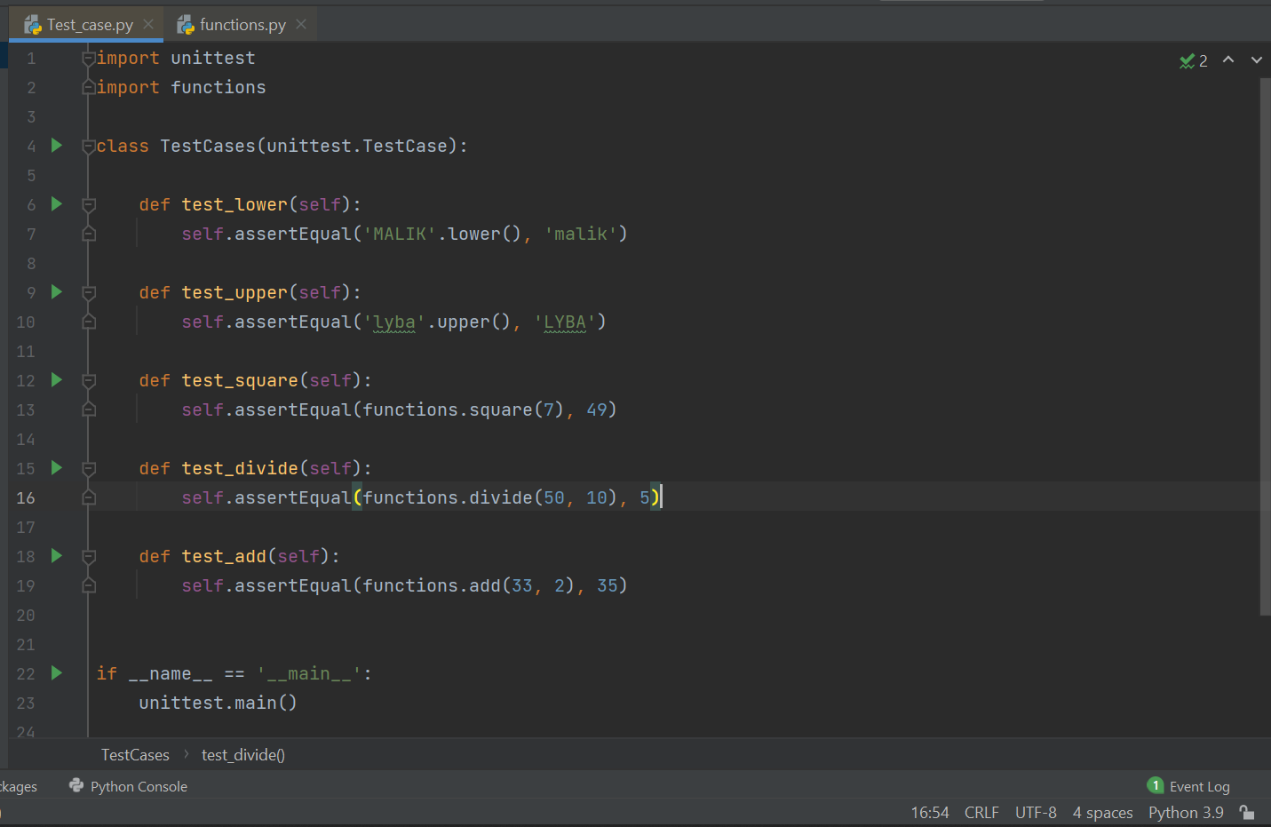

In this I have selected my programming language python, in which I have chosen 5 test cases, all of them show the pass versions of them., the first one is of changing the upper-case letters to the lower case, and the expected output is given, it matches the expected output then the test is pass otherwise its failed.

Then the second one is changing lower case to upper case letters.

The third one is of taking the square of the given number, the expected given output is displayed.

The fourth one is for divide, and the fifth test case is for addition.

***The Functions:***

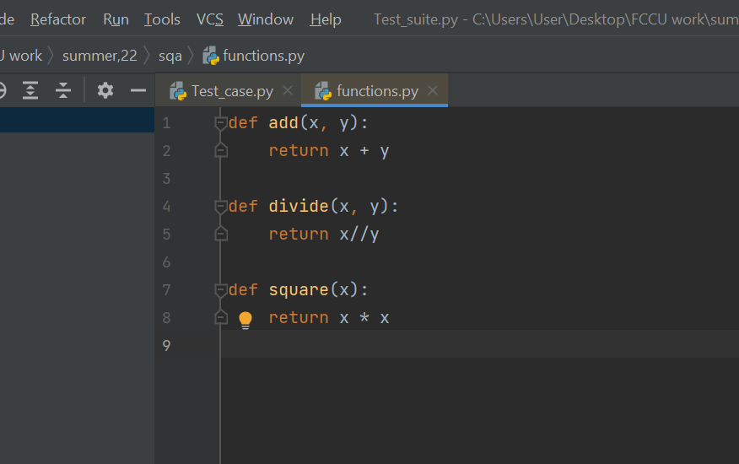

These are the functions or the formulas I used for calculating the outputs.

***Fail Test Cases:***

Now if we look for the fail outputs, by changing the outputs, and if they do not match them, then the test will fail. For example, for the (test lower) the failure case is as follows:

The First fail case is:

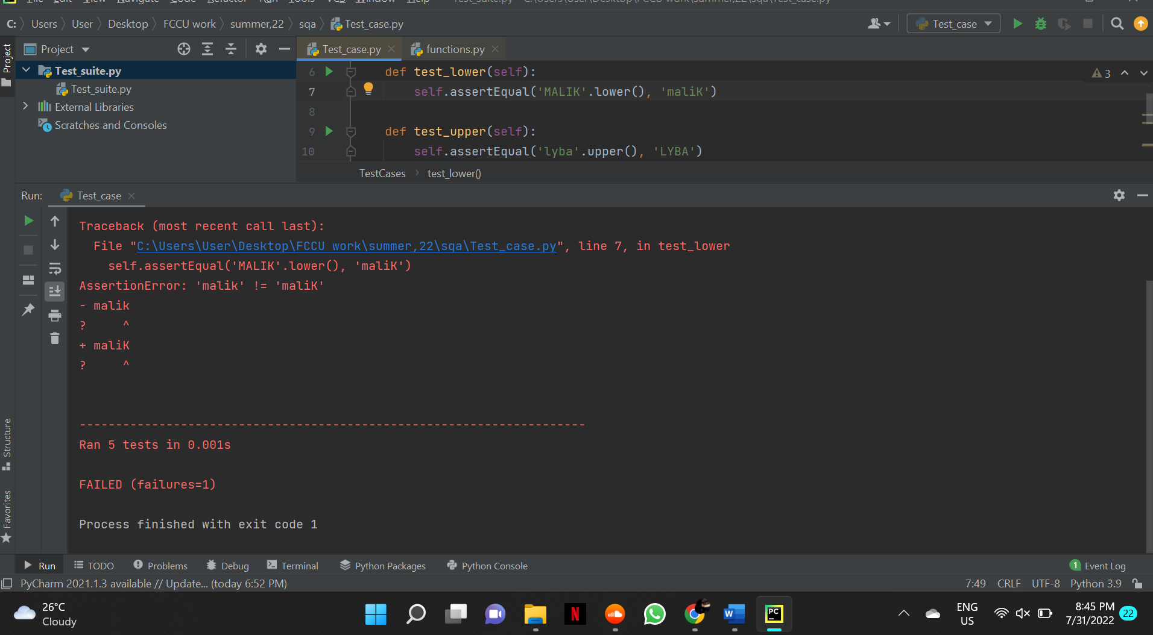

Now for the second one:

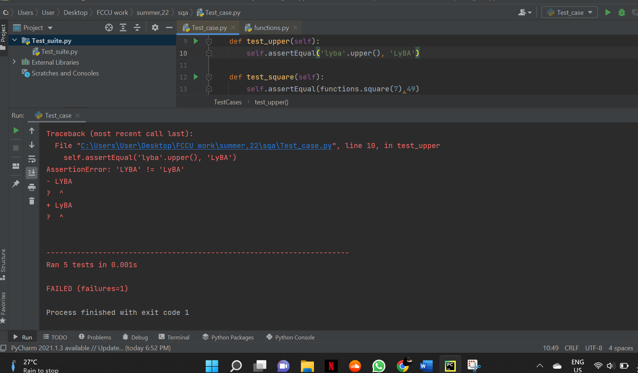

The third fail case:

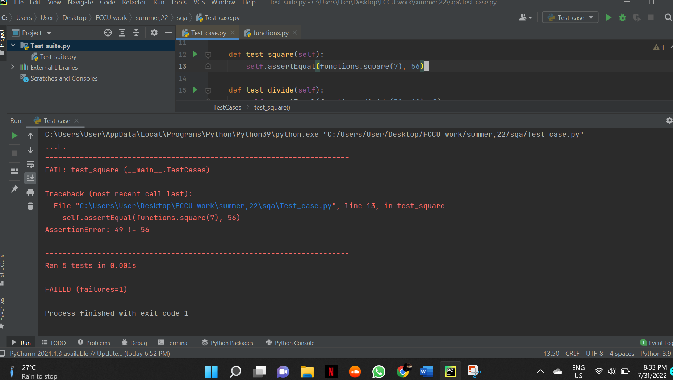

The fourth fail case:

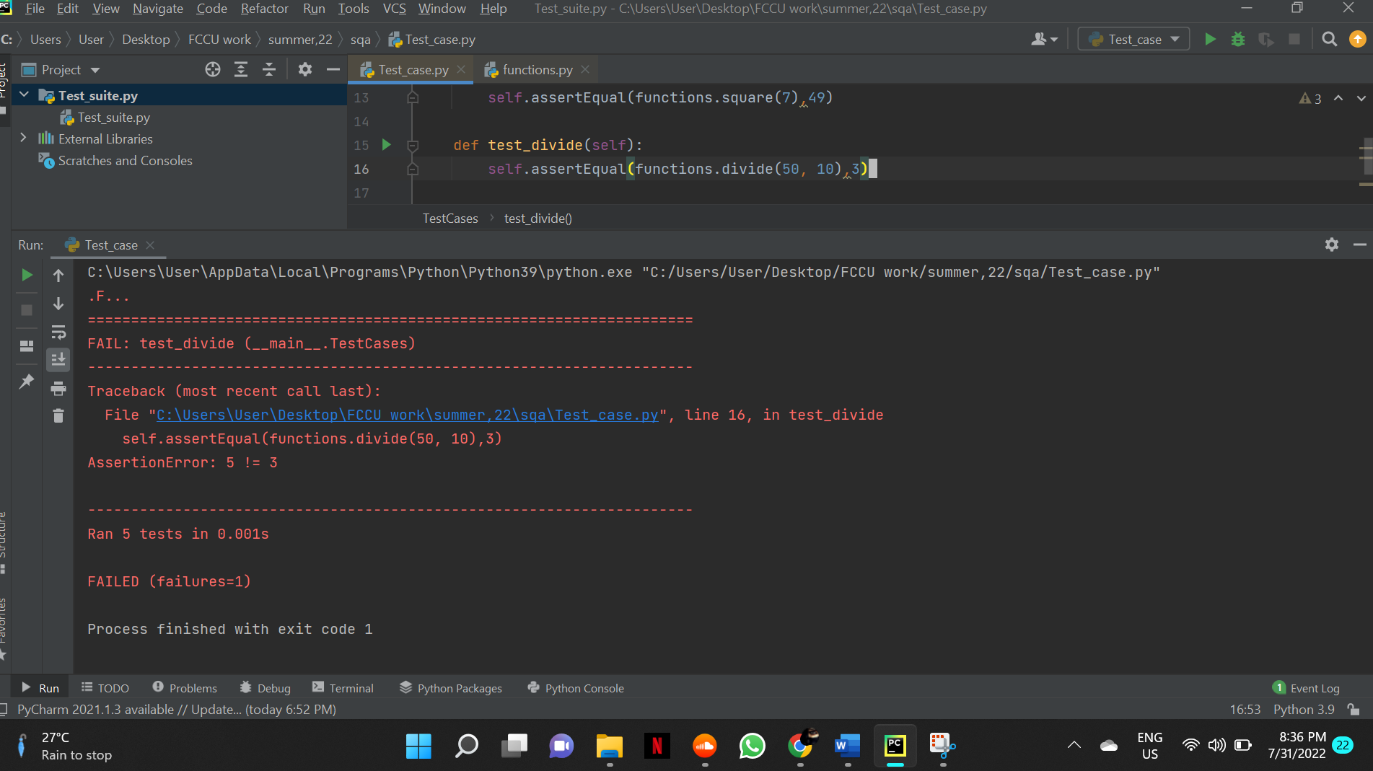

The fifth test failed will result if the output expected will be changed:

